Wordpress jobs

Frontend/WordPress Developer
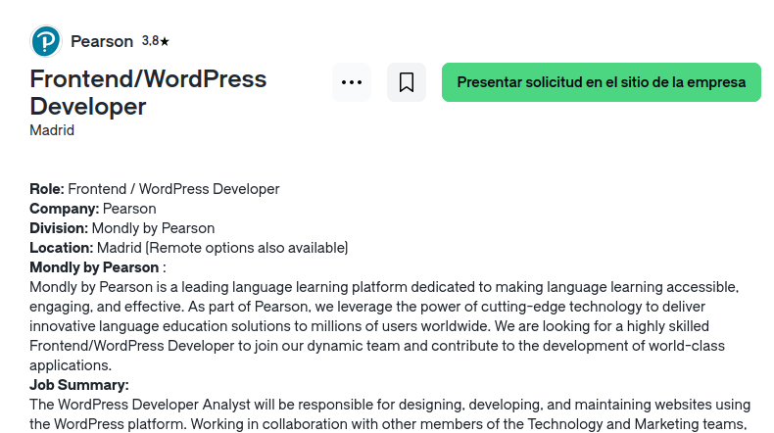

WordPress Developer
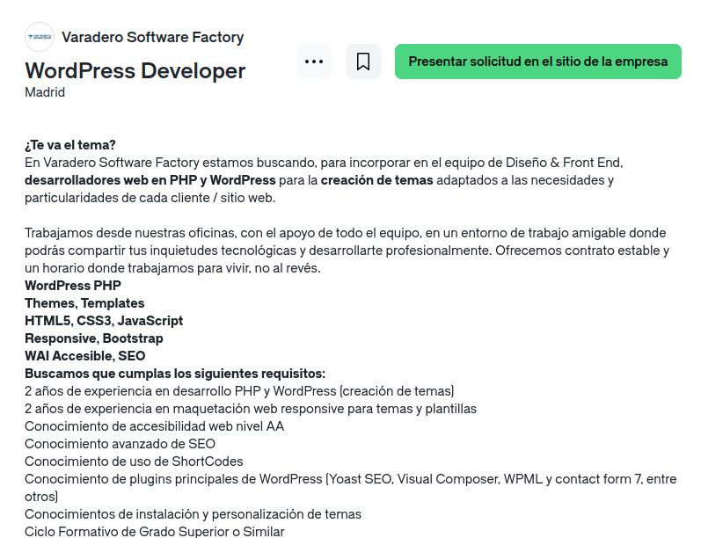

Wordpress Web Developer
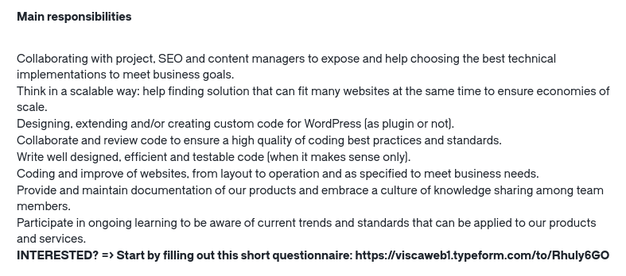

WORDPRESS DESIGNER & DEVELOPER
